|  |  |
| --- | --- |
| **Canon EOS-1D X Mark III camera**  Máy ảnh Canon EOS-1D X Mark III  Canon EOS 1DX III 1 Canon EOS 1DX III 9 Canon EOS 1DX III 8 Canon EOS 1DX III 2 | **Featured information:**   * 191 focus points through viewfinder * 20.1MP Full-Frame CMOS sensor * Canon Dual Pixel CMOS AF 525 optional zones * Record 4K 60fps video   Price : 5000$  **Specifications:**   * **Sensor Format:** Full-Frame (1x Crop Factor) * **Resolution:** 20.1 megapixels * **Size photo:** 5472 x 3648 * **Image Proportions:** 3:2 * **Sensor Type:** CMOS * **Image Format:** JPEG, Raw, HEIF * **Anti-Vibration:** In-body 5-axis electronic image stabilisation * **Lens Mount:** Canon EF |

**Description:**

**Canon EOS 1D X Mark III has a new sensor, new imaging system**

The Canon EOS 1D X Mark III uses a completely new 20.1MP sensor combined with the DIGIC moire application.

**Stylish Design**

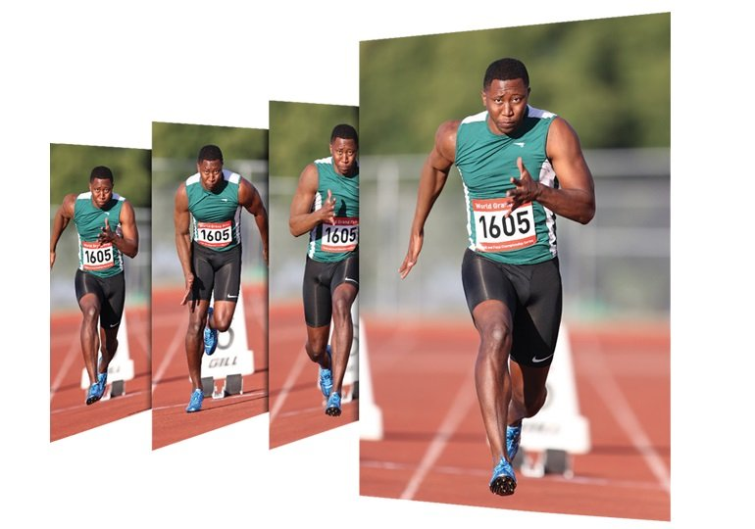

The Canon EOS 1D X Mark III features a wide color space with HDR HEIF imaging options, providing greater highlight detail when displayed on compatible monitors and printers. In addition, clarity-in-camera control is also new that allows adjustment of contrast and midtone.